Batch: E-2 Roll No.: 16010123325

Experiment No. 02

Grade: AA / AB / BB / BC / CC / CD /DD

Signature of the Staff In-charge with date

TITLE: Develop and demonstrate the usage of inline, internal and external style sheet using CSS

AIM: To demonstrate the CSS.
______________________________________________________________________
Expected Outcome of Experiment: Use CSS to prepare the layout of web pages.
________________________________________________________________
Books/ Journals/ Websites referred:

- https://www.w3schools.com/css/

_____________________________________________________________________

CSS :

Internal CSS

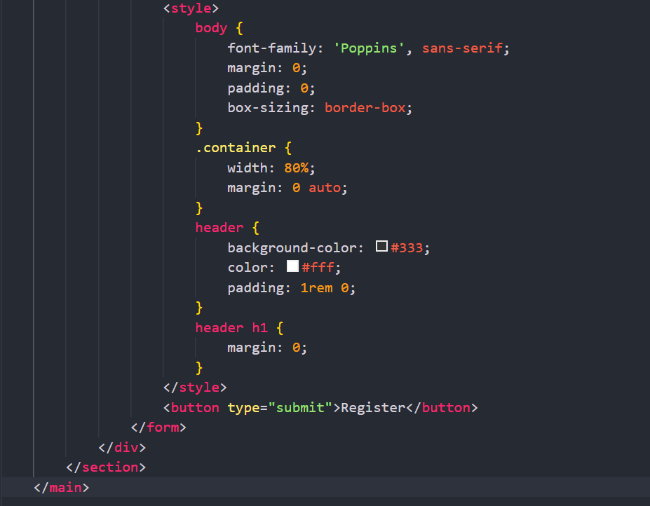
External CSS
* {
margin: 0;
padding: 0;
box-sizing: border-box;
}

body {
font-family: 'Poppins', sans-serif;
line-height: 1.6;
color: #333;
background-color: #f0f4f8;
}

.container {
width: 90%;
max-width: 1200px;
margin: 0 auto;
padding: 0 20px;
}

header {
background: #2c3e50;
padding: 1rem 0;
position: fixed;
width: 100%;
top: 0;
z-index: 1000;
box-shadow: 0 2px 10px rgba(0, 0, 0, 0.1);
}

header .container {
display: flex;
justify-content: space-between;
align-items: center;
}

header h1 {
color: #ecf0f1;
font-size: 2rem;
font-weight: 600;
}

nav {
display: flex;
gap: 1rem;
}

.nav-link {
color: #ecf0f1;
text-decoration: none;
padding: 0.5rem 1rem;
border-radius: 5px;
transition: background-color 0.3s ease, color 0.3s ease;
}

.nav-link:hover,
.nav-link.active {
background-color: #34495e;
color: #3498db;
}

main {
padding-top: 5rem;
min-height: calc(100vh - 5rem - 60px);
}

section {
display: none;
padding: 4rem 0;
}

section.active {
display: block;
animation: fadeIn 0.5s ease-in-out;
}

@keyframes fadeIn {
from { opacity: 0; transform: translateY(20px); }
to { opacity: 1; transform: translateY(0); }
}

h2 {
font-size: 2.5rem;
margin-bottom: 2rem;
color: #2c3e50;
text-align: center;
}

.hero {
background: linear-gradient(135deg, #3498db, #8e44ad);
color: #fff;
text-align: center;
padding: 6rem 2rem;
border-radius: 10px;
box-shadow: 0 4px 15px rgba(0, 0, 0, 0.1);
}

.hero h2 {
font-size: 3rem;
margin-bottom: 1rem;
color: #fff;
}

.hero p {
font-size: 1.2rem;
max-width: 600px;
margin: 0 auto 2rem;
}

.cta-button {
display: inline-block;
padding: 0.75rem 1.5rem;
background-color: #2ecc71;
color: #fff;
text-decoration: none;
border-radius: 30px;
font-size: 1rem;
transition: all 0.3s ease;
border: none;
cursor: pointer;
}

.cta-button:hover {
background-color: #27ae60;
transform: translateY(-3px);
box-shadow: 0 4px 10px rgba(0, 0, 0, 0.2);
}

.table-container {
background: #fff;
border-radius: 10px;
overflow: hidden;
box-shadow: 0 4px 15px rgba(0, 0, 0, 0.1);
}

table {
width: 100%;
border-collapse: collapse;
}

th, td {
padding: 1rem;
text-align: left;
border-bottom: 1px solid #ecf0f1;
}

thead {
background: #34495e;
color: #ecf0f1;
}

tbody tr:hover {
background: #f8f9fa;
}

.in-stock {
color: #2ecc71;
}

.out-of-stock {
color: #e74c3c;
}

.auth-form {
max-width: 400px;
margin: 0 auto;
background: #fff;
padding: 2rem;
border-radius: 10px;
box-shadow: 0 4px 15px rgba(0, 0, 0, 0.1);
}

.form-group {
margin-bottom: 1rem;
}

label {
display: block;
margin-bottom: 0.5rem;
color: #34495e;
}

input[type="text"],
input[type="email"],
input[type="password"] {
width: 100%;
padding: 0.75rem;
border: 1px solid #bdc3c7;
border-radius: 5px;
font-size: 1rem;
transition: border-color 0.3s ease;
}

input[type="text"]:focus,
input[type="email"]:focus,
input[type="password"]:focus {
outline: none;
border-color: #3498db;
}

button[type="submit"] {
width: 100%;
padding: 0.75rem;
background: #3498db;
color: #fff;
border: none;
border-radius: 5px;
cursor: pointer;
font-size: 1rem;
transition: background 0.3s ease;
}

button[type="submit"]:hover {
background: #2980b9;
}

.checkbox-label {
display: flex;
align-items: center;
user-select: none;
}

.checkbox-label input {
margin-right: 0.5rem;
}

.form-footer {
margin-top: 1rem;
text-align: center;
}

.forgot-password {
color: #3498db;
text-decoration: none;
}

.forgot-password:hover {
text-decoration: underline;
}

footer {
background: #2c3e50;
color: #ecf0f1;
text-align: center;
padding: 1rem 0;
position: relative;
bottom: 0;
width: 100%;
}

@media (max-width: 768px) {
header .container {
flex-direction: column;
align-items: flex-start;
}

nav {
margin-top: 1rem;
}

.hero h2 {
font-size: 2.5rem;
}

.table-container {
overflow-x: auto;
}

table {
font-size: 0.9rem;
}
}

@media (max-width: 480px) {
.hero {
padding: 4rem 1rem;
}

.hero h2 {
font-size: 2rem;
}

.auth-form {
padding: 1.5rem;
}
}

Inline CSS

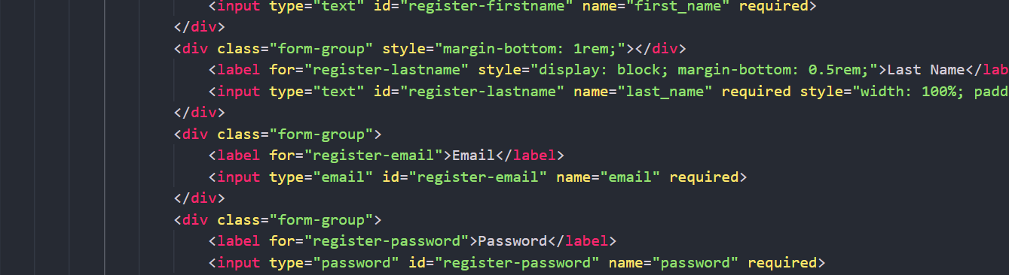

Description of the application implemented with output:

The Book Shop Website is a user-friendly application designed to provide an intuitive experience for users to browse, register, login. It includes the following functionalities:
- Home Page
- Login Page
- Catalogue Page
- Registration Page

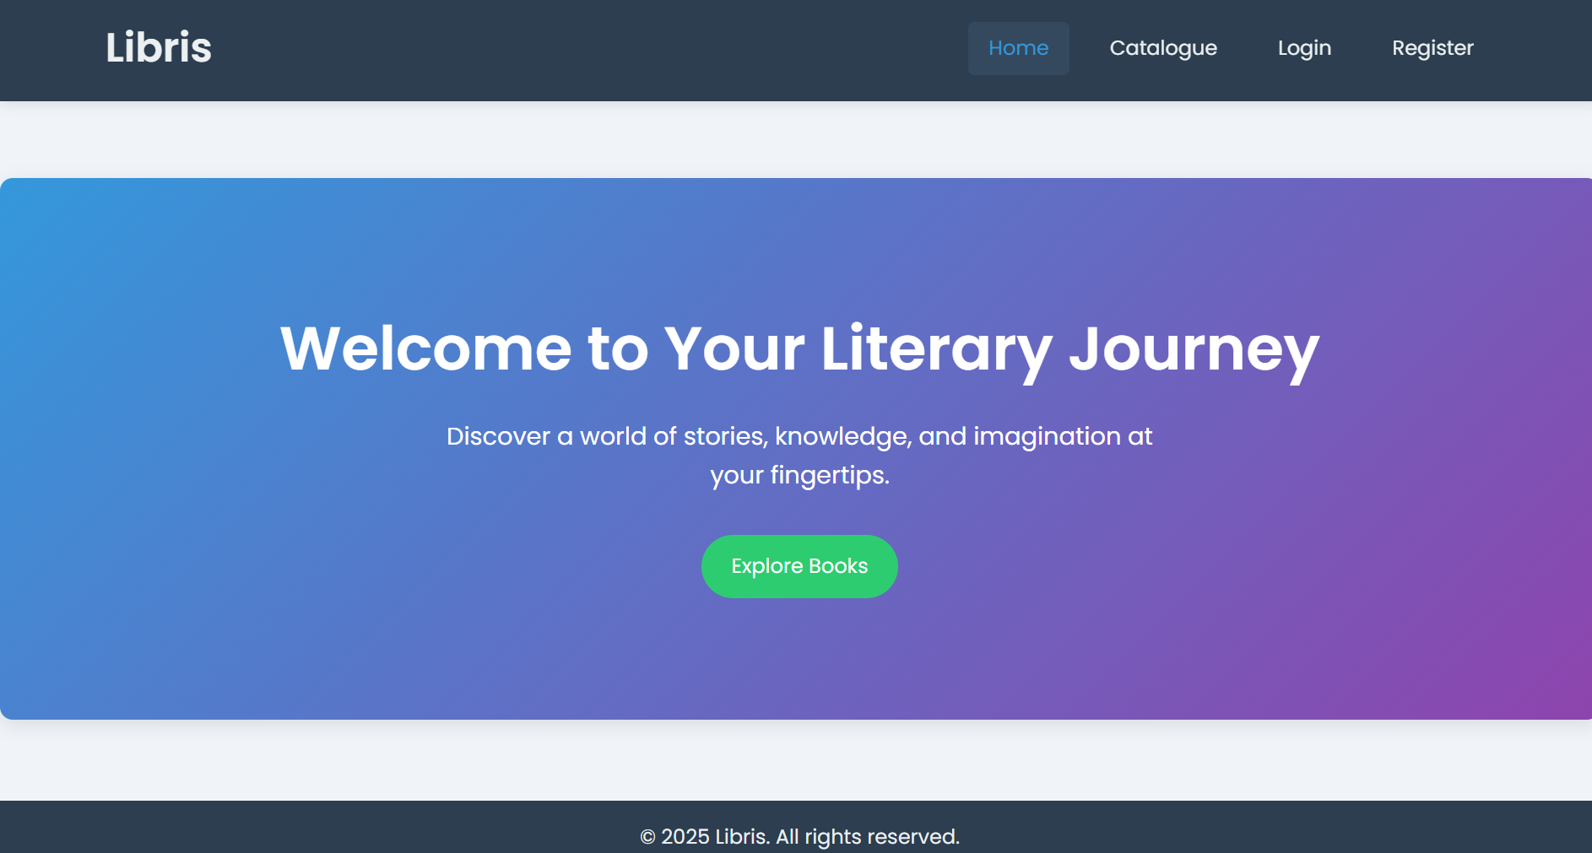

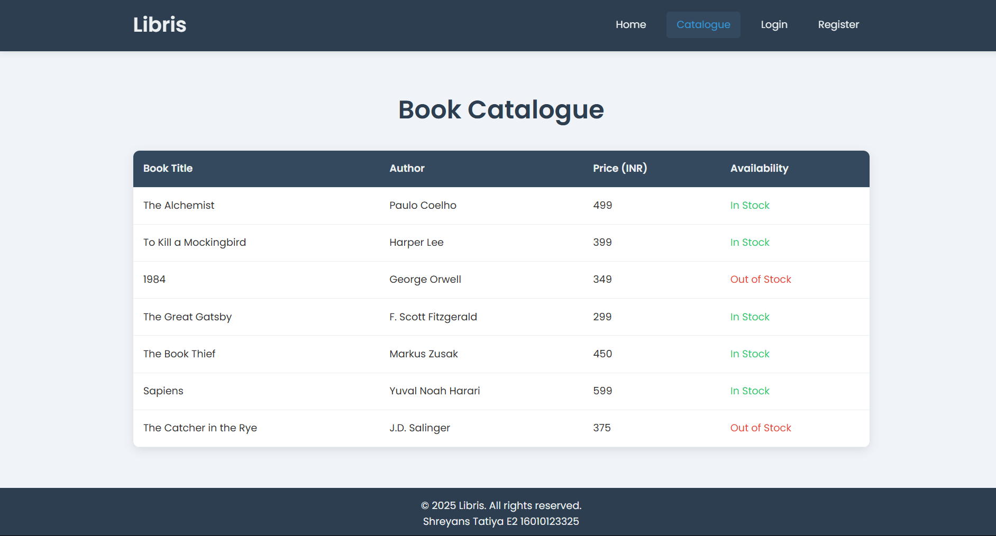
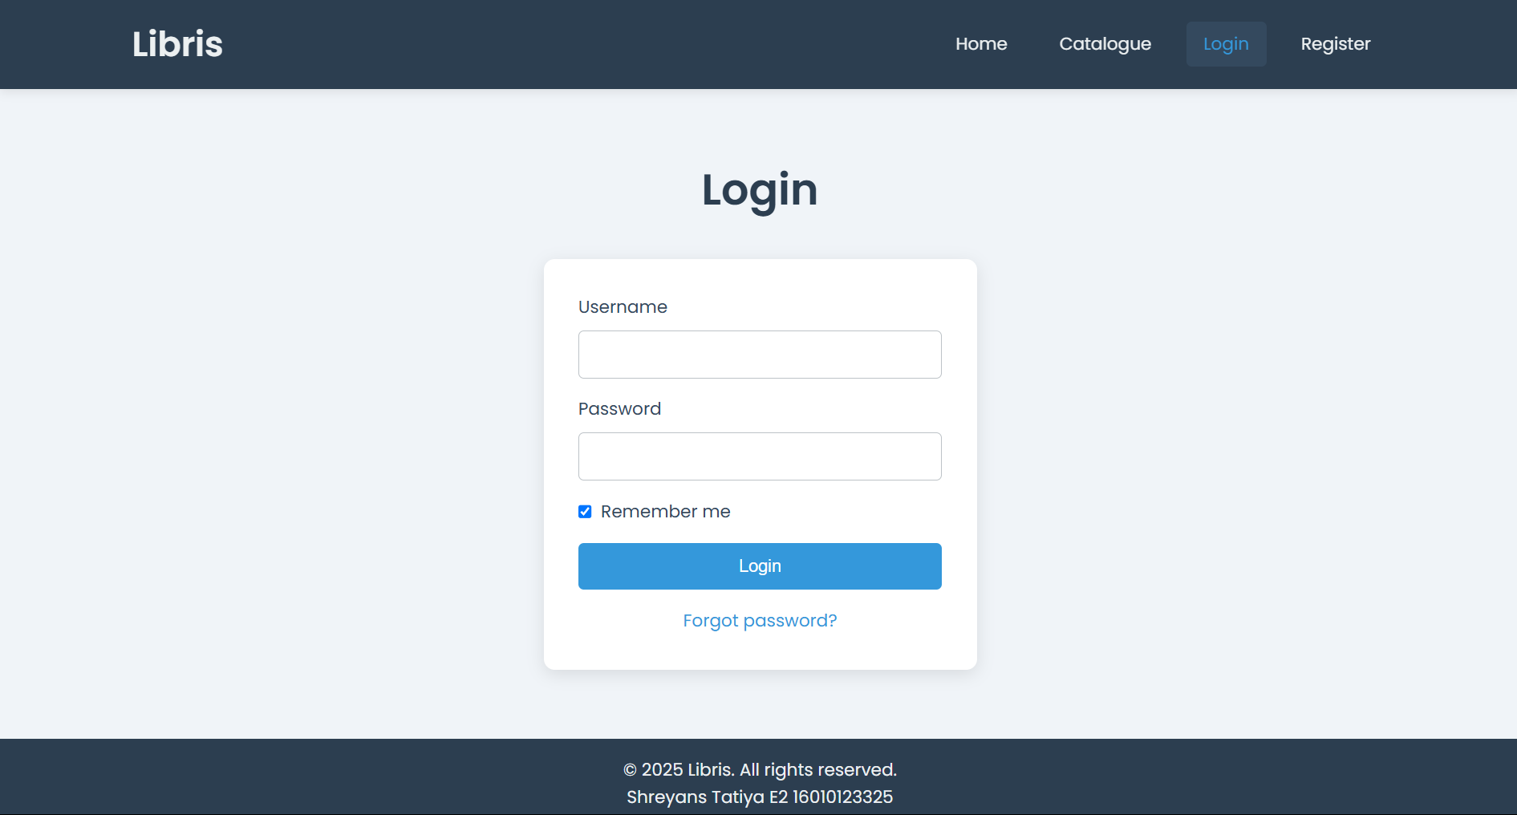

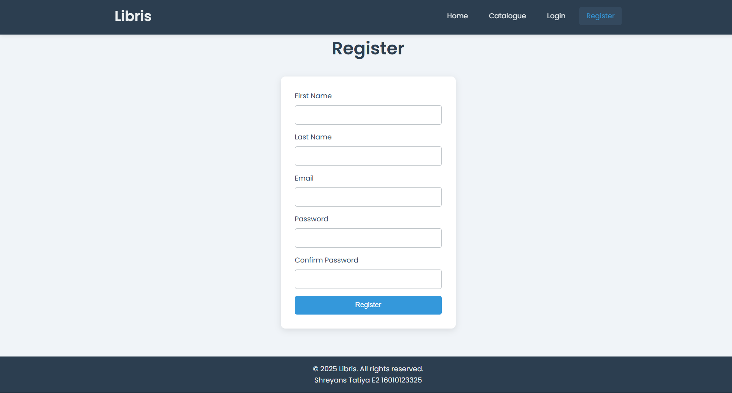

Post Lab Objective with Answer

- What is the Box model in CSS?
The Box Model in CSS describes how HTML elements are rendered in terms of space and layout. Each element is represented as a rectangular box comprising the following layers :
- Content: The area where text, images, or other content appear.
- Padding: Space between the content and the element's border.
- Border: Surrounds the padding; the thickness and style can be set.
- Margin: Space outside the border separating the element from other elements.
- What are the advantages of using CSS?
- Separation of Content: Allows separation of content (HTML) and presentation (CSS).
- Consistency: Ensures a uniform design across multiple pages with a single stylesheet.
- Reusability: Styles can be reused across multiple HTML elements and pages.
- Flexibility: Easily adaptable to changes; updating a CSS file reflects across all linked documents.
- Responsive Design: Allows creating layouts that adapt to different devices and screen sizes.

- What are the limitations of CSS?
- Browser Compatibility: Styles may render differently in various browsers.
- No Logic: CSS lacks programming constructs like loops, conditions, or variables.
- Dependency: Relies on HTML structure, which can limit flexibility in certain designs.
- Over-Specificity: Excessive use of specific selectors can complicate the styling process.
- Limited Interactivity: Pure CSS is unsuitable for dynamic behavior (like logic-based interactions).

- What are the different types of Selectors in CSS?
  - Universal Selector (*): Targets all elements.
  - Type Selector: Matches specific element tags.
  - Class Selector (.classname): Matches elements with a specific class.
  - ID Selector (#id): Matches an element with a specific ID.
  - Group Selector: Applies the same styles to multiple elements.

Date: Signature of faculty in-charge

